|  |
| --- |
| José Coronil Álvarez (joscoralv@alum.us.es)  Miguel García Vizcaíno (miggarviz@alum.us.es)  Javier Ignacio Milá de la Roca Dos Santos (javmildos@alum.us.es)  Emilio Manuel Vázquez Cruz (emivazcru@alum.us.es)  Group C1.028  5-16-2025 |

|  |
| --- |
| Acme AirNav Solutions, Inc. |
| **Testing Report** |
| https://github.com/Emilio-115/DP2-Acme-ANS |



Contents

Executive Summary 2

Revision Table 2

Introduction 3

Content 3

Tests Cases 3

Airports 3

Test Coverage 3

Airports 3

Performance Analysis 5

Computer 1 5

Computer 2 6

Comparison 7

Conclusions 7

Bibliography 7

# Executive Summary

This report documents the tests implemented for airport features. All required test cases were created and executed, covering legal and illegal actions. Most features functioned as expected, any bug was found during the recording due to the previous informal testing. Most reachable lines of code were covered by the tests. The tests were executed in two different computers to make the comparison.

# Revision Table

|  |  |  |
| --- | --- | --- |
| Revision number | Date | Description |
| 1 | 26/05/2025 | Initial version |

# Introduction

This document contains the analysis of the tests recorded to ensure the proper function of the requirements developed for airport features in the Acme-ANS project. It includes a summary of the test cases developed for the features implemented, covering users use cases and hacking attempts. It also reports on the achieved test coverage and a basic performance comparison between two computers.

# Content

Following the guidelines provided, safe and hack test cases were recorded for airport features aiming for a high coverage, there is a performance test and a comparison between two computers.

## Tests Cases

The following is a list of the test cases implemented, grouped by feature:

### Airports

* **List.safe**: This test checks that the airports are correctly listed to the administrator
* **List.hack**: The test verify that another realm cannot access to the list of airports.
* **show.hack**: This test ensure that a wrong realm cannot access to the show of an airport.
* **create.safe**, **update.safe**: These tests ensure you can properly use create and update airport legal features, they check that all the validations work by using a big variety of values for each field of the form, also different combinations are tested.
* **create.hack, update.hack**: These tests check that a panic view is shown when trying to modify another entity changing the id field of the form.

## Test Coverage

The following is a summary of the coverage achieved for all relevant files

### Airports

* **Validator** **(83,6%):**All the missing coverage comes from safety null checks that are never actually executed due to being an impossible branch of execution, all domain logic is 100% covered.
* **Services of features (100%)**

100% of coverage was successfully achieved in the all the services of the airport features

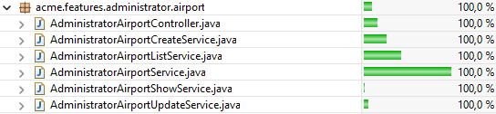

## Performance Analysis

The performance analysis was produced following the instructions, for 2 different computers running the project, the objective of this section is to analyze both and compare them. This data was extracted from the execution of airport tests.

### Computer 1

For computer 1, the testing resulted in a 95% confidence interval from 15.09ms to 17.80ms and a mean of 16.44ms. The request with the highest response time was /administrator/airport/create with 85.21ms.

|  |  |  |  |  |  |
| --- | --- | --- | --- | --- | --- |
| *Response Time* | |  |  |  |  |
|  |  |  | Interval(ms) | 15.0917452 | 17.8057642 |
| Media | 16.4487547 |  | Interval(s) | 0.01509175 | 0.01780576 |
| Error típico | 0.68817491 |  |  |  |  |
| Mediana | 16.2265 |  |  |  |  |
| Moda | #N/D |  |  |  |  |
| Desviación estándar | 9.75656322 |  |  |  |  |
| Varianza de la muestra | 95.1905258 |  |  |  |  |
| Curtosis | 13.3862365 |  |  |  |  |
| Coeficiente de asimetría | 2.28138825 |  |  |  |  |
| Rango | 82.8921 |  |  |  |  |
| Mínimo | 2.3187 |  |  |  |  |
| Máximo | 85.2108 |  |  |  |  |
| Suma | 3306.1997 |  |  |  |  |
| Cuenta | 201 |  |  |  |  |
| Nivel de confianza(95,0%) | 1.3570095 |  |  |  |  |

### Computer 2

For computer 2, the interval was from 16.10ms to 19.21ms, with a mean of 17.66ms. The request with the highest response time was /administrator/airport/create with 76.53ms

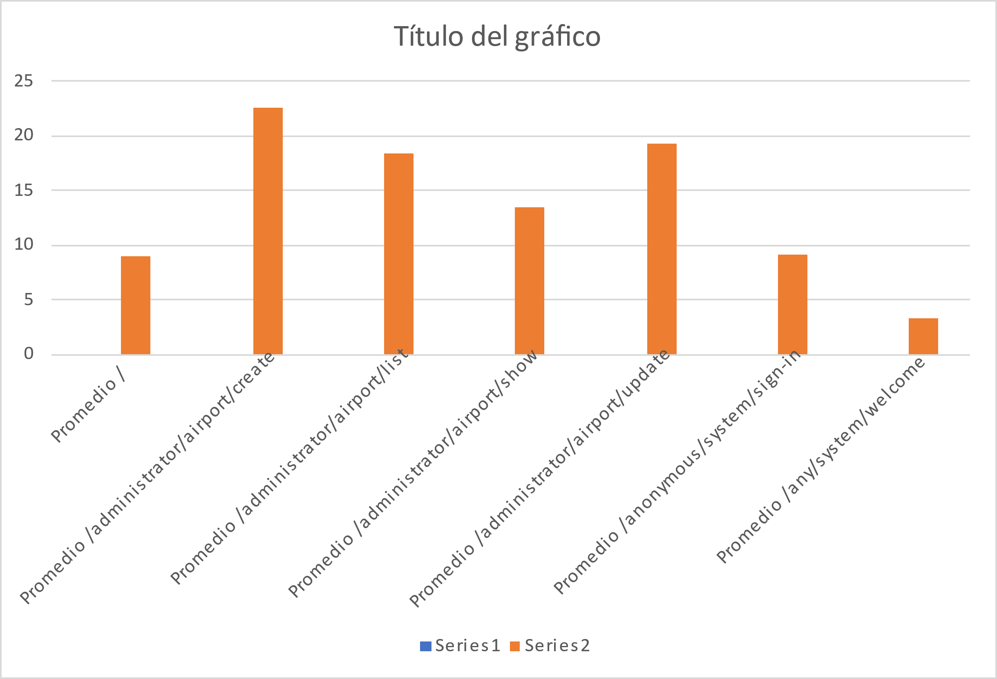

|  |  |  |  |  |  |
| --- | --- | --- | --- | --- | --- |
| *Response Time* | |  |  |  |  |
|  |  |  | Interval(ms) | 16.1082632 | 19.2161697 |
| Media | 17.6622164 |  | Interval(s) | 0.01610826 | 0.01921617 |
| Error típico | 0.78805022 |  |  |  |  |
| Mediana | 17.1031 |  |  |  |  |
| Moda | #N/D |  |  |  |  |
| Desviación estándar | 11.1725402 |  |  |  |  |
| Varianza de la muestra | 124.825655 |  |  |  |  |
| Curtosis | 7.78052111 |  |  |  |  |
| Coeficiente de asimetría | 1.96779195 |  |  |  |  |
| Rango | 74.705 |  |  |  |  |
| Mínimo | 1.8302 |  |  |  |  |
| Máximo | 76.5352 |  |  |  |  |
| Suma | 3550.1055 |  |  |  |  |
| Cuenta | 201 |  |  |  |  |
| Nivel de confianza(95,0%) | 1.55395326 |  |  |  |  |

### Comparison

The two-sample z-test for means resulted in a P(Z<=z) two-tail value of 0.24, which is over the alpha value for the 95% confidence level (0.05). With this in mind there is not enough evidence to ensure there is a significative change. Even with this we can see how the mean is higher in the PC2

|  |  |  |
| --- | --- | --- |
|  | *PC1* | *PC2* |
| Media | 16.4487547 | 17.6622164 |
| Varianza (conocida) | 95.1905258 | 124.825655 |
| Observaciones | 201 | 201 |
| Diferencia hipotética de las medias | 0 |  |
| z | -1.15983654 |  |
| P(Z<=z) una cola | 0.12305768 |  |
| Valor crítico de z (una cola) | 1.64485363 |  |
| P(Z<=z) dos colas | 0.24611537 |  |
| Valor crítico de z (dos colas) | 1.95996398 |  |

# Conclusions

We deeply tested all airport manager features to ensure maximum quality, having 100% tests passing, a really high percentage of test coverage and uncovered branches are not coverable.

After the performance analysis we can see the impact in the metrics due to the hardware specifications of each computer.

# Bibliography

Intentionally blank.